Read the following story. After reading, use the table on the other side of the sheet to show how Todorov’s narrative theory can be applied to the text.
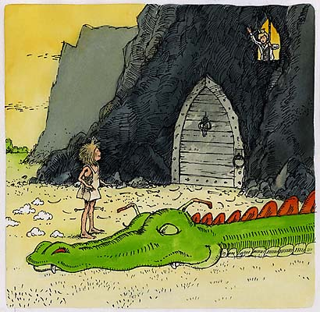
Emily was a princess who lived a long time ago, back in the days of dragons and knights. In her time, people expected princesses to be pretty, petite and totally incapable of looking after themselves. Emily hated this stereotype. She thought it was outdated and totally bizarre. In fact, she was fed up with people thinking she should sit around waiting for some wimpy Prince Charming to find her. Instead, she decided to take matters into her own hands, and set out on a journey to find the perfect man.
A few days into her trek she came across a dragon who was singeing the hair off of a freckle-faced boy. He was wearing a crown, so Emily decided that surely he must be a prince. Being a resourceful and independent princess, she decided to set a trap for the dragon in order to save the boy. She set everything up, and managed to trick the dragon into following her by making herself look as appetizing as possible.
“You’re just a silly little girl, and even though you’re hardly worth eating, I’m going to toast you to a crisp and have you for pudding!” boomed the dragon.
No sooner had he said this then the floor he was standing on gave way. He crashed rather noisily into a very deep well, his fire put out once and for all.
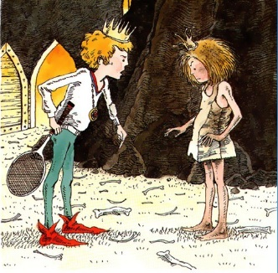
Emily strolled up to the boy and asked him his name.
“Prince Matthew,” he replied.
“That’ll do,’ she said. “Where do you live?”
“In a castle with my mum and dad, the King and Queen of Happily-Ever-After,” he replied.
“Excellent!” she said.
And with that, she and Matthew walked off together towards their Happily-Ever-After.

Todorov’s Narrative Structure Task 1
How closely does the narrative follow Todorov’s five narrative stages? Fill in details from the story in the appropriate boxes.
Stage 1: Equilibrium

Stage 2: Disruption

Stage 3: Character recognises the disruption and sets about resolving the problem

Stage 4: Character overcomes the obstacles to repair the disruption

Stage 5: The situation is resolved and equilibrium is restored

How closely could you apply Todorov’s theory to the story you have studied?

Todorov’s Narrative Structure Task 2
Come up with an idea for a new film in which the plot follows Todorov's narrative structure. You may like to use the hero/villain that you've created earlier in the unit, and link your narrative to your DVD cover.

Stage 1: Equilibrium

Stage 2: Disruption

Stage 3: Character recognises the disruption and sets about resolving the problem

Stage 4: Character overcomes the obstacles to repair the disruption

Stage 5: The situation is resolved and equilibrium is restored

Todorov’s Narrative Structure Plenary
How closely does the narrative follow Todorov’s five narrative stages? Fill in details from the short film in the appropriate boxes.
Stage 1: Equilibrium

Stage 2: Disruption

Stage 3: Character recognises the disruption and sets about resolving the problem

Stage 4: Character overcomes the obstacles to repair the disruption

Stage 5: The situation is resolved and equilibrium is restored

How closely could you apply Todorov’s theory to the short film you have studied?

