A stern defence of the vuvuzela
Thursday 17th June 2010, 6:00AM BST.
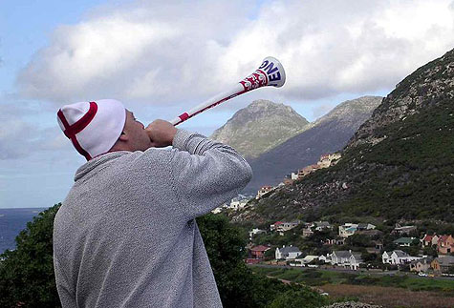
Black Country man Paul Geiss believes the much-debated vuvuzela should be accepted as a part of this World Cup’s culture in his adopted country.
As the first round of matches comes to an end, it’s clear that despite the excitement for us in South Africa the watching eyes of the world are not enjoying everything so far.
The concerns over the Jabulani ball are growing daily and the number of goals scored is nowhere near as high as in previous tournaments.
The cautious play expressed so far has been surprising but, for me, the most disappointing thing to come out of week one is the attempt to bully the hosts into muzzling the vuvuzela.
For sure it takes some getting used to. For the past three years every game I have been to or watched on TV here has been dominated by the unique and very loud sound.
It certainly makes for a much different matchday atmosphere than I ever experienced at Walsall. Just minutes into my first game as a spectator in South Africa I knew that football was never going to be the same for me again.
The important thing is to respect the fact that this is South African football culture. This really is how we watch football down here. The World Cup is all about bringing the nations of the world together and embracing the different footballing cultures – even if that is a cheap plastic trumpet.
Go out and buy a vuvuzela – I hear that supermarkets in the United Kingdom are now importing them.
They are great fun and you will find that the noise generated in real life is actually different to that experienced over a TV feed.
The TV does produce a monotone sound, whereas at the real matches I have attended in this World Cup you can hear the crowd over the vuvuzelas and it is possible to talk to the guys around you.
But there is a definite vuvuzela etiquette. You should always point them up into the sky, so the sound travels up.
My worst experience here is South Africa involved sitting through a tense cup local cup tie with a small child behind me, his arms gradually tired from holding a huge vuvuzela.
As extra time loomed, I was deafened by the sound blasting straight into my ear rather than up into the sky.
With FIFA backing our right to keep on trumpeting, it looks like football viewers must either turn TV sets to mute or join in the fun.
Remember to avoid pets and elderly relatives, but if you follow the etiquette the vuvuzela really can grow on you.
Read more: http://www.expressandstar.com/world-cup/2010/06/17/a-stern-defence-of-the-vuvuzela/#ixzz0r7isdX1Z

