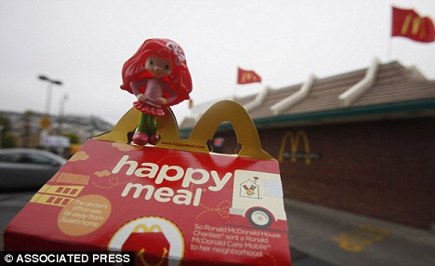
Free toys with Happy Meals lure children into eating junk food, claims mother suing McDonald's
By Daily Mail Reporter
UPDATED: 12:10, 16 December 2010
McDonald’s is facing a two-pronged attack from an angry parent and a consumer health organization, who hope they can stop the fast-food giant using toys to market its Happy Meals.
The Center for Science has teamed up with Monet Parham after the mother-of-two sued McDonald’s yesterday, claiming it is violating several consumer protection laws.
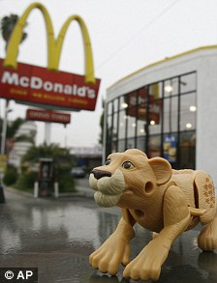
They believe that the company’s Happy Meals marketing tempts vulnerable youngsters into the chains just for the toys, and in turn makes them obese and addicted to poor quality, high-fat junk food.
The main reason Mrs Parham’s six-year-old daughter, Maya, asks to go to McDonald’s is to get toys based on Barbie, i-Carly, Shrek, or Strawberry Shortcake.
The Sacramento mother said: 'What kids see as a fun toy, I now realise is a sophisticated, hi-tech marketing scheme that's designed to put McDonald's between me and my daughters.
'For the sake of other parents and their children, I want McDonald's to stop interfering with my family.
‘This litany of requests [to eat at McDonald's] is draining and very frustrating for children. I would like this practice to stop.’

Mrs Parham's lawyers, who filed the lawsuit in state court in San Francisco yesterday, have asked that it be certified as a class action and CSPI litigation director Stephen Gardner said: ‘The lawsuit is about the change, not the money.
‘[McDonald's is engaged in a] highly sophisticated scheme to use the bait of toys to exploit children's developmental immaturity and subvert parental authority.
‘McDonald's advertising of Happy Meals with toys is deceptive and unfair to children, unfair to parents, and in violation of California law.
‘Under the law, you don't blame the victim of deceptive practices.’
Mr Gardner said McDonald's is a bigger offender than tobacco companies when it comes to unfair marketing because it targets very young children with tantalising toys and advertisements.
The CSPI has a track record of getting the food industry to change its practices.
Snack and cereal maker Kellogg Co. agreed to a settlement with the centre that set nutrition standards for the foods Kellogg's could advertise to children.
KFC agreed to phase out oils high in trans fats after the centre dropped a lawsuit over KFC's use of partially hydrogenated oils.
McDonald’s has been in the firing line lately from public health officials, parents and lawmakers who are frustrated with rising childhood obesity rates and weak anti-obesity efforts from restaurant operators, which are largely self-regulated.
Those critics say poorly funded education campaigns don't have a chance against fast-food companies, which according to a recent report spent more than $4.2billion in 2009 on marketing and advertising.
Such frustrations recently prompted lawmakers in San Francisco and nearby Santa Clara County to pass laws that will require restaurant kids' meals to meet nutritional standards before they can be sold with toys.
San Francisco recently prohibited toys in meals with more than 600 calories or more than 35 per cent of their calories from fat.
McDonald's began distributing Happy Meals in America 31 years ago, in 1979, and will defend its brand, reputation and food.
'We stand on our 30-year track record of providing a fun experience for kids and families at McDonald's,' the company said in a statement.
'We are proud of our Happy Meals and intend to vigorously defend our brand, our reputation and our food,' said McDonald's spokesman Bridget Coffing.
'We listen to our customers, and parents consistently tell us they approve of our Happy Meals.'

