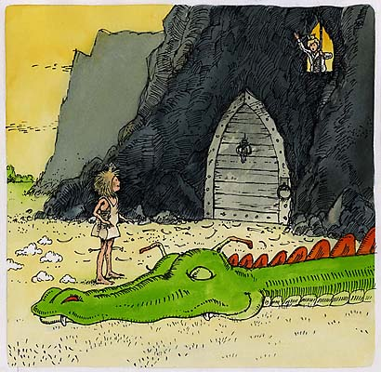

1. Using the table on the reverse side, show how Todorov’s theory can be applied to Emily’s story.
2. Working with members at your table, find record examples of each of the stages in two films you know well.
3. Think of your own simple story featuring a small boy or girl. Write a 50-word story that follows this narrative structure.

Emily was sick of waiting around for a wimpy prince to come and ask for her hand in marriage, so she decided to find one herself. She soon came upon a dragon who was singeing the top of a freckle-faced boy’s head.

Being a resourceful princess, Emily set a trap for the dragon and then tricked him into following her.

‘You’re just a silly girl, and even though it’s hardly worh it, I’m going to toast you to a crisp and have you for pudding!’ boomed the dragon. Just then, the branches he was standing on gave way, and he fell down a very deep well, his fire put out for once and for all.

Emily returned to the boy. ‘What’s your name?’ she asked.

‘Prince Matthew,’ said the boy.

‘That’ll do nicely,’ said Emily. ‘Where do you live?’

‘In Happily-Ever-After,’ he replied.

‘That’ll do nicely too,’ said Emily. And with that, she and Matthew rode off together to Happily-Ever-After.